**Site Map:**

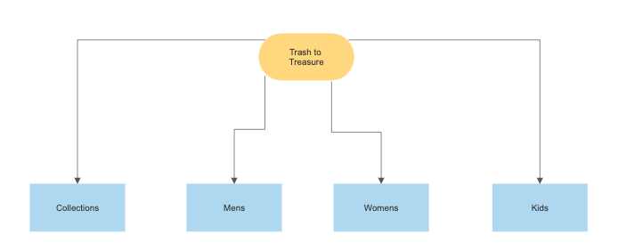

(*Cloud.smartdraw.com*)

**Wireframe:**

|  |
| --- |
| **Title** |
| **Nav Bar** |
| **Body** |
| **Footer** |

**HTML Validation:**

